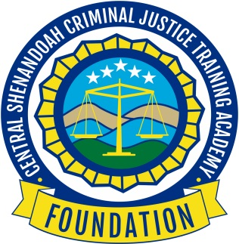

“Training our Criminal Justice Professionals today

to meet the challenges of tomorrow”

The Central Shenandoah Criminal Justice Training Academy Foundation was established to create opportunities that allow law enforcement, dispatch, and jail officials to have the necessary training and support required to be effective in the communities we serve.

The Central Shenandoah Criminal Justice Training Academy (CSCJTA) serves 58 law enforcement agencies, jails, ECC’s across four State Police service regions that cover over 15,000 square miles.
These 2,000 members deserve training on the most current practices available, opportunities to put these classroom concepts into practice, and to have access to resources to better promote safety. As society continues to move forward with more technology, improved access to items that in the past were difficult to obtain, it is vital to prepare our members with the tools needed to address these issues.
The goal for the Foundation is to provide additional training dollars, $50,000 per fiscal year.

For more information or to make a donation please contact Andrew McNally, President
amcnally@centralshenandoahacademy.com

3045 Lee Highway
Weyers Cave VA 24486

540-234-9191

